1.Write an algorithm to find the area of the triangle

STEP 1: START

STEP 2: TAKE INPUT HEIGHT AND BASE

STEP 3: CALCULATE THE AREA OF TRIANGLE USING FORMULA AREA = (HEIGHT\*BASE)/2

STEP 4: PRINT THE AREA

STEP 5: STOP

2. Draw a flowchart for adding the integers from 1 to 100 and to print the sum.

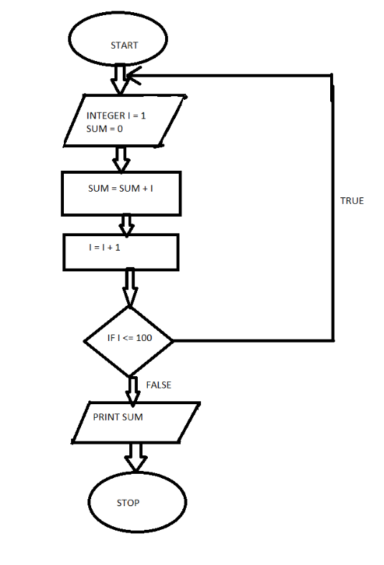

3.Write a pseudo code to perform the basic arithmetic operations.

STEP 1: START

STEP 2: ENTER VALUE OF FIRST VARIABLE X, X <- 1

STEP 3: ENTER VALUE OF SECOND VARIABLE Y, Y <- 2

STEP 4: CALCULATE Z = X + Y, Z <- 1+2

STEP 5: PRINT THE SUM OF THE VARIABLES Z, Z <- 3

STEP 6: END OF THE PROGRAM

4. Draw a flowchart to find the factorial of given positive integer N.

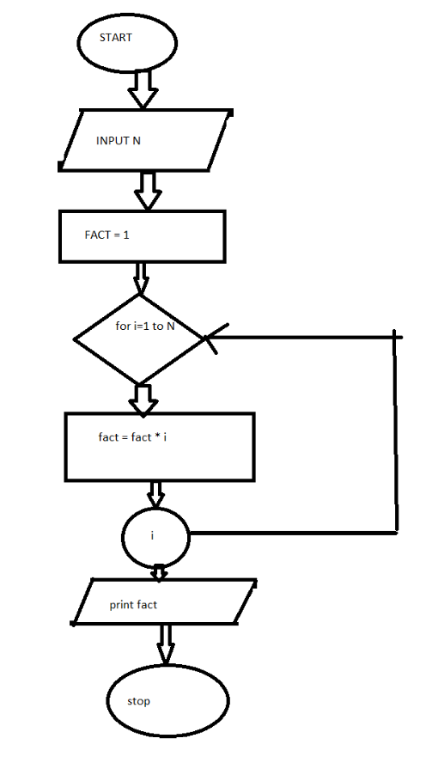

5. Develop a flowchart to illustrate how to make a Land phone telephone call.

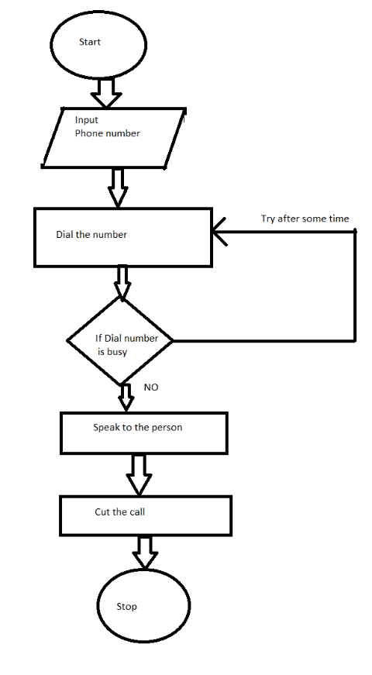

6. Write an algorithm to calculate the simple interest using the formula.

STEP 1: START

STEP 2: READ THE THREE INPUT VALUES i.e. PRINCIPAL AMOUNT, RATE, TIME

STEP 3: CALCULATE SIMPLE INTEREST USING FORMULA, SI = (PRINCIPAL AMOUNT\*RATE\*TIME)/100

STEP 4: PRINT THE SIMPLE INTEREST

STEP 5: END

7. Write an algorithm to find the largest of three numbers X, Y, Z

STEP 1: START

STEP 2: READ THE THREE INPUT VALUES i.e. A,B AND C

STEP 3: if (A>B)

BIG = A

else

BIG = B

STEP 4: BIG = C

STEP 5: PRINT THE LARGEST NUMBER I.E. BIG

STEP 6: STOP

8. Write an algorithm which will test whether a given integer value is prime or not.

STEP 1: START

STEP 2: READ AN INPUT VALUE i.e. num

STEP 3: INITIALIZE A VARIABLE temp TO 0

STEP 4: MAKE A FOR LOOP, from 2 to num/2

STEP 5: IF (temp==0)

print "Num is prime"

else

print "Num is not prime"

STEP 6: STOP

9. Draw a flowchart to find out the biggest of the three unequal positive numbers.

